MEDIA CONTACTS:
Noelle Thurlow, thurlow.noelle@gmail.com, (617) 438-5708
Lara Cohn, press@betterwaterfront.org, (646) 596-6377
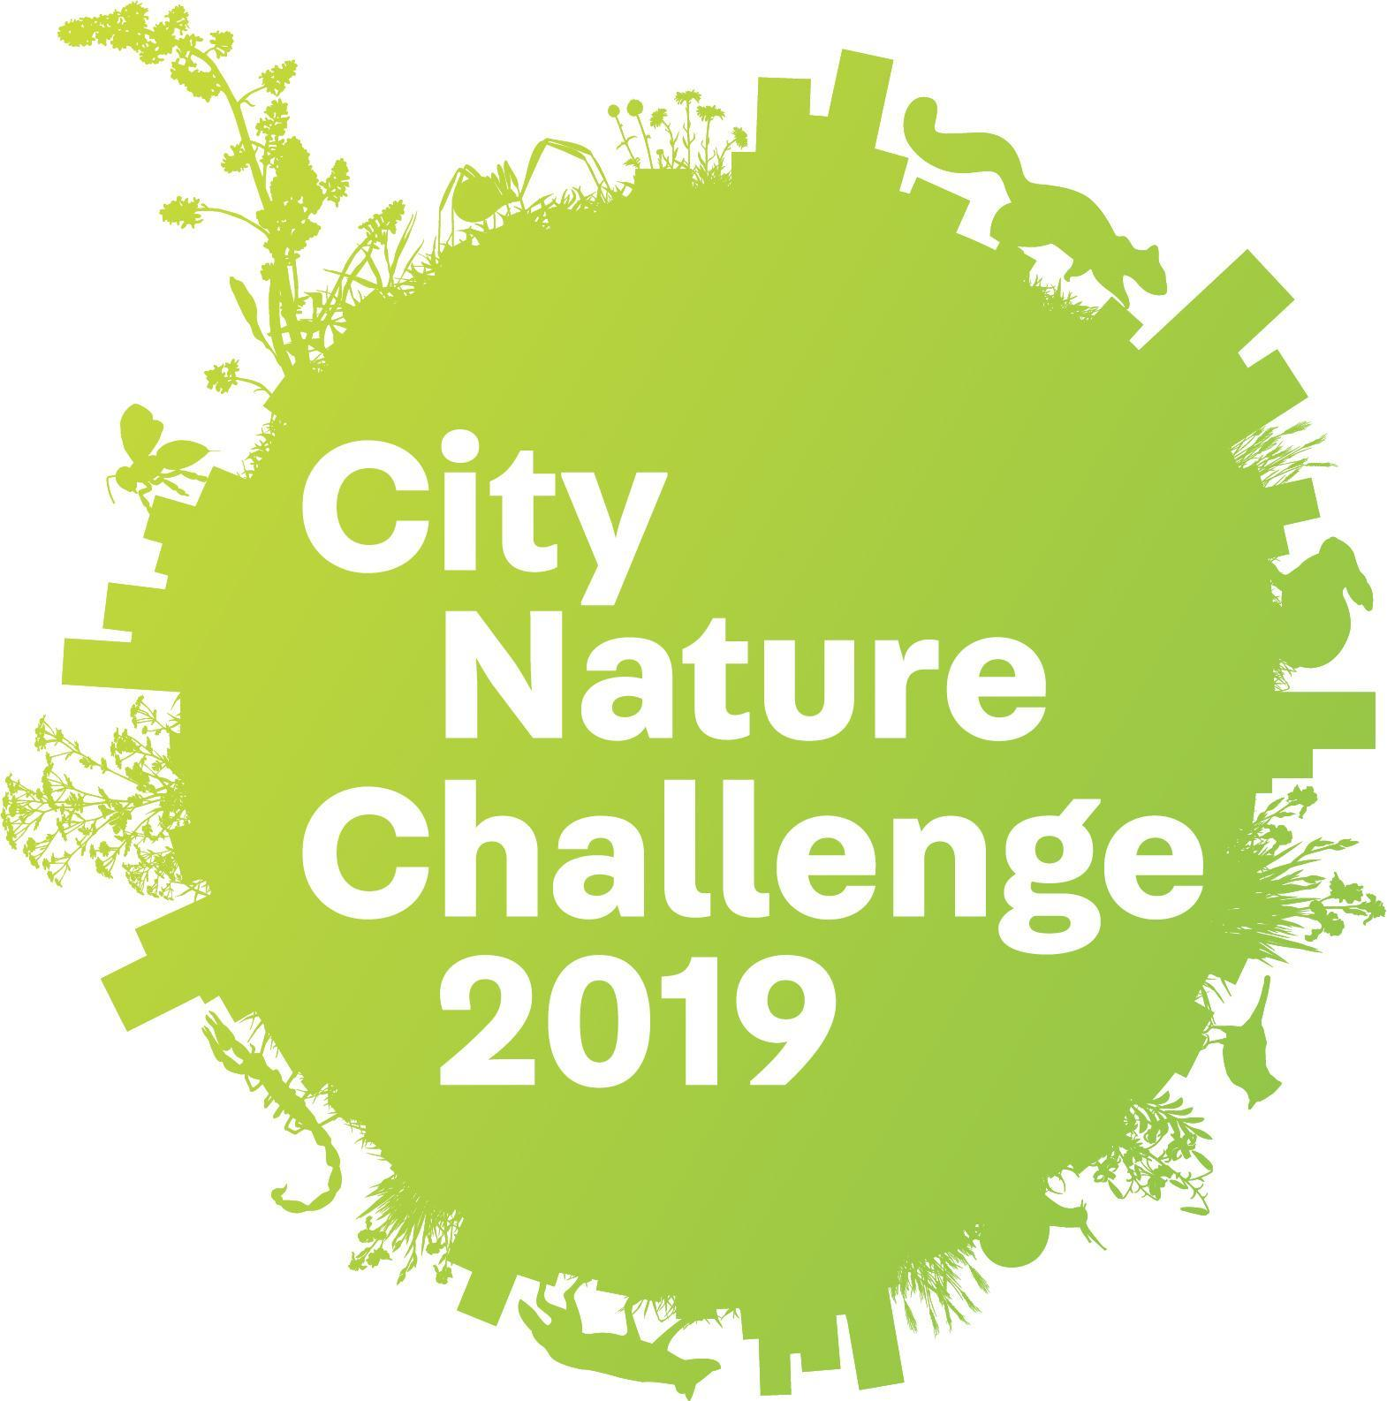
CITIZEN AND COMMUNITY SCIENTISTS COMPETE IN CITY NATURE CHALLENGE 2019: HOBOKEN BEACH COVE APRIL 26-29

Fourth annual challenge grows to over 150 participating cities on six continents; results announced on May 6

HOBOKEN, NJ (April 18, 2019) – As citizen and community science initiatives build momentum around the world, this year’s fourth annual City Nature Challenge will expand to more than 150 cities across six continents. Join Resilience Paddle Sports, the City of Hoboken, and Fund for a Better Waterfront as we compete with hundreds of other cities worldwide to observe, document and share images of wildlife – plants, insects and wild animals – right here in Hoboken. Kicking off at the Hoboken Cove Beach on Friday, April 26, 2019 at 9am, the Challenge runs through Monday, April 29, 2019.

The global event calls on current and aspiring citizen scientists, nature and science fans, and people of all ages and education backgrounds to observe and submit pictures of wild plants, animals, and fungi using the free mobile app iNaturalist. Identification of photographed species will be crowdsourced through the online community April 30 – May 5 and results will be announced on May 6.

Nature exists in every city, and one of the best ways to study it is by connecting scientists and the community through citizen science. As global human populations become increasingly concentrated in cities, it’s more important than ever to document urban biodiversity and help ensure the future of plants and wildlife. Large pools of data built through iNaturalist, natural history museums, and science organizations help authorities make informed conservation decisions that allow humans to coexist sustainably with the plants and animals in their neighborhoods.

After launching the first-ever City Nature Challenge in 2016, the Natural History Museum of Los Angeles County (NHM) and San Francisco’s California Academy of Sciences (CAS) are hosting their fourth—and much larger—effort. Last year’s four-day challenge invited participants in 68 cities around the world to observe and submit pictures of wildlife they encountered using iNaturalist. Participants added over 400,000 observations of nature to iNaturalist, and scientists continue to use these data to understand and conserve urban wildlife.

This year, the Challenge is expanding, and organizers estimate that 750,000 observations will be made by over 25,000 people in over 150 participating cities. For both budding and veteran citizen scientists, participating is easy:

- Find wildlife. It can be any wild plant, animal, fungi, slime mold, or any other evidence of life (scat, fur, tracks, shells, carcasses!) found in your participating city.
- Take pictures of what you find using iNaturalist or your city’s chosen platform.
- Learn more as your observations get identified!
Scientists can’t be everywhere at once, so without community observations, they’d miss some incredible finds. During the 2018 City Nature Challenge, an observation of a hammerhead worm in the San Francisco Bay Area marked the first-ever recording of this species, which is native to Asia, in the U.S. In central Texas, the bracted twistflower—a candidate for federal protection—bloomed in deep purple hues across its only known home in the Edwards Plateau. In Hong Kong, observations of an incense tree that inspired the city’s name (Hong Kong translates to “scented harbor”) helped document how the once-abundant tree has declined across its native range. And the observation of an endangered songbird flitting through swamps outside of Bogotá, Colombia renewed hope for the future of this rare bird. Many other endangered, endemic, or data deficient species were recorded during the City Nature Challenge: This influx of information gives scientists, educators, urban planners, and policymakers insight into the biodiversity of urban locales throughout the world.

Events in Hoboken are free, but we ask that you please RSVP here: https://www.eventbrite.com/city-nature-challenge-Hoboken-tickets

All events take place at the Hoboken Cove Beach, Sinatra Drive between 10th and 11th Street, Hoboken, NJ.

Schedule of Events (Saturday & Sunday)

9 AM and 3 PM Beach cleanup and trash documentation
Clean up the beach and log what you find, helping scientists, environmentalists, and cities better understand the pollution that threatens our river.

10 AM and Noon Bioblitz @ the Hoboken Cove
Find and record as many species as you can! Trained facilitators will be on hand to help you identify, upload pictures, and learn about your discoveries. Each bioblitz session will be last approximately 90 minutes.

All day, both days: Ongoing Water Quality Sampling and Testing
Facilitators will provide water quality mini-workshops. Participants will have the opportunity to try out scientific equipment and learn about the widespread problem of Combined Sewer Overflow systems. The discussion will focus on the way we pollute the very water that gives us life – and what we can do to clean it up and protect it for the future.

Want to learn more? Check out Hoboken’s own City Nature Challenge page at https://www.inaturalist.org/projects/city-nature-challenge-2019-hoboken and don’t forget to download the iNaturalist app before you start! Check it out here: https://www.inaturalist.org/.

# # #

